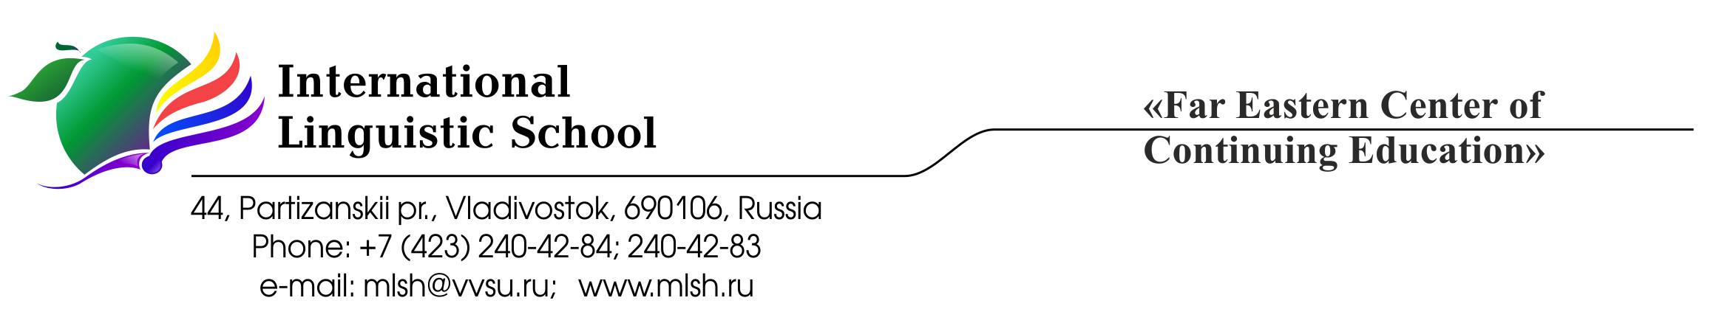

Assessment Policy
The ILS mission is to create for our students an educational environment that encourages an intelligent, inquisitive approach to learning and a proactive approach to life; that teaches children how to help create a better, safer world; and that fosters love and respect for one’s own culture and history as well as the history and culture of other nations.
In keeping with our slogan “Education for Life”, ILS uses the International Baccalaureate programme as an instrument for students’ cognitive motivation and a means of encouraging them to be responsible, active people with a thirst for knowledge that will carry them successfully through life.
It is important for our graduates to be skilled decision makers and problem solvers, guided by proper personal values, critical, creative thinking, and effective action in a wide range of situations and in cooperation with others and with due care for people’s health and safety. (ILS Mission Statement)
In line with the School’s Mission Statement assessment is an integral part of the learning process. Its one purpose is to provide detailed feedback to teachers and students on the nature of the students’ strengths and weaknesses and to help develop the students’ capabilities. Its another purpose is to measure the level of each student’s achievement. A variety of assessment tasks are used in order to ensure that students have an opportunity to demonstrate achievement through the aims and objectives for each subject. Assessment is the tool used to evaluate teaching and learning and to provide the School community with information to guide future instruction.
Types of Assessment
Formative assessment represents the process of gathering, analysing, interpreting and using the evidence to improve student learning and to help students to achieve their potential. It is integrated into the daily learning process and provides teachers and students with information about how learning is progressing and how the teaching and learning techniques should be adjusted.
Summative assessment is concerned with measuring student performance against established assessment criteria to judge levels of attainment. It occurs at the end of a period of learning when students are given the opportunity to demonstrate what they have learned. It is used to support the communication of information about achievement to the School community.
Formal assessment is defined as assessment directly contributing to the final qualification and represents the final summative assessment. Most formal assessment is external and includes examinations or work completed during the course and then sent to an external examiner. Some formal assessment is internal, requiring the teacher to mark the work before it is moderated by an external moderator.
Assessment Practices
The grading scale in ILS is based on grades 1-7 with 7 corresponding to excellent performance and 1 reflecting very poor performance. Assessment tasks are graded according to assessment criteria issued by IB and are specific for each subject. These assessment criteria are explained to students by their subject teachers at the beginning of each school year. Where appropriate, the percentage of correct answers is converted into a grade according to the following grade boundaries:
95% - 100% 7
85% - 94% 6
70% - 84% 5
56% - 69% 4
41% - 55% 3
26% - 40% 2
14% - 25% 1
Students are evaluated and given grades at the end of each semester (December and May) and they receive the final grade at the end of each school year. Preliminary grades are given to students in the middle of each semester (October and March).
Student’s achievements are communicated to parents in the form of quarterly progress reports that contain all marks the student have so far received for each subject, preliminary and final grades and may be accompanied by subject teachers’ written comments on the student’s performance. In cases when a student is performing badly and if there is a risk that the student may receive a failing semester grade in any of the subjects the parents are contacted immediately via email, phone or face-to-face. Conferences for parents are held once each semester where the student’s progress can be discussed with individual IB teachers. Individual meetings are arranged whenever there is a request.
Teachers use a variety of assessment instruments such as written assignments, oral presentations, portfolios, laboratory reports, tests, examinations, research papers, peer and self-assessment in order to assess students’ progress in connection with aims and objectives specific for each subject and prepare the students for the IB summative assessment. A timeline for internal and external IB requirements is created and published to help students plan ahead and manage their workload.
The students are given predicted grades on each subject including Theory of Knowledge and Extended Essay in March. These grades are based on their semester grades in the 11th and 12th years, their internal assessment and the outcomes of the subject mock examinations held in March and April.
Absenteeism and late submission
The students receive zero for the assessments which were missed due to absenteeism. They are given the opportunity to address the missed assessments during the week following their return to school, however, the received zero is added to the nearest evaluation. The same rule applies if the deadlines for the assessment are not met. Students receiving a failing semester or yearly grade in any of the subjects in year 11 will not be allowed to be promoted to year 12.
Assessment and Inclusion
The School recognizes the fact that students affected by temporary, long-term or permanent disability or illness may require special arrangements to help them meet their assessment goals. The students who miss the important assessment component due to a documented illness are given an opportunity to complete the task during the week following their return to school. In case of prolonged absence (2 weeks or more) students receive additional sessions with the subject teachers to help them cope with the course work. Request for inclusive assessment arrangements for final IB exams must be submitted to IBO at the beginning of grade 12.
Assessment and Academic Honesty
The School community believes that the best results can be achieved only in the environment where everybody’s contribution is rightfully acknowledged.
In line with the IB Learner Profile that states IB learners strive to be “principled - acting with integrity and honesty, with a strong sense of fairness and justice, and with respect for the dignity and rights of people everywhere, taking responsibility for the actions and their consequences” ILS community places high value on the work done honestly.
All instances of academically dishonest behavior are reported to the IB DP coordinator and the student’s parents are informed. The student receives zero as a grade for the work which is found to be academically dishonest. The descriptions of all the cases of academic misconduct are kept in the student’s school file and this information can be the reason to decline the request to write a recommendation letter for college admission. The School retains the right to mention the cases of academic misconduct if the college or university sends the application papers directly to the IB Coordinator.
Bibliography:
IB publications:
Diploma Programme: From principles into practice (for use from August 2015)
Diploma Programme assessment: Principles and practice
Guidelines for developing a school assessment policy in the Diploma Programme

